|  |  |  |  |
| --- | --- | --- | --- |
| **Name of Student: NINAD AVINASH PATIL** | | | |
| **Roll No: 33** | | **Lab Practical Number: 4(C)** | |
| **Title of Lab Practical: Create ASP.NET web form to place order for online Grocery shop.** | | | |
| **DOP: 06/04/2021** | | **DOS: 13/04/2021** | |
| **CO Mapped: CO1** | **PO Mapped: PO3, PO5, PO7,**  **PO12, PSO1, PSO2** | **Faculty Signature:** | **Marks:** |

**Practical No 4(C)**

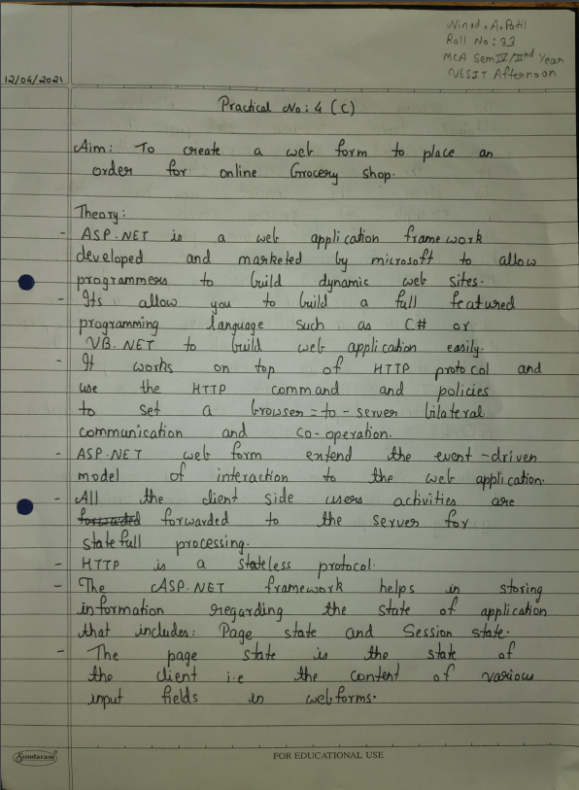

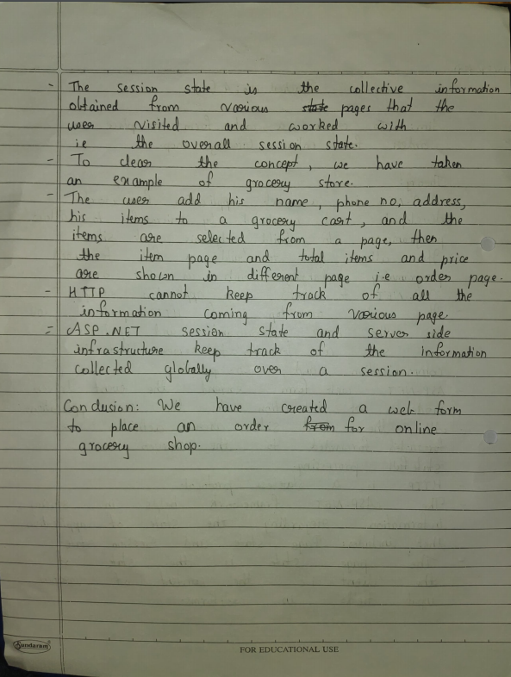

**Code:**

**WebForm1.aspx**

<%@ Page Language="C#" AutoEventWireup="true" CodeBehind="WebForm1.aspx.cs" Inherits="P4C.WebForm1" %>

<!DOCTYPE html PUBLIC "-//W3C//DTD XHTML 1.0 Transitional//EN" "http://www.w3.org/TR/xhtml1/DTD/xhtml1-transitional.dtd">

<html xmlns="http://www.w3.org/1999/xhtml">

<head id="Head1" runat="server">

<title>Online Grocery Shop</title>

<script type="text/javascript">

function popup() {

alert("Order placed successfully!"); }

</script>

</head>

<body>

<form id="form1" runat="server">

<div> <table> <tr> <td>

<asp:Label ID="Label1" runat="server" Text="Enter your name"></asp:Label>

</td> <td>

<asp:TextBox ID="txtName" runat="server" AutoPostBack="True"></asp:TextBox>

</td> </tr> <tr> <td>

<asp:Label ID="Label2" runat="server" Text="Enter your mobile"></asp:Label>

</td> <td>

<asp:TextBox ID="txtMobile" runat="server" AutoPostBack="True"></asp:TextBox>

</td> </tr> <tr> <td>

<asp:Label ID="Label3" runat="server" Text="Enter your address"></asp:Label>

</td> <td>

<asp:TextBox ID="txtAddress" runat="server" TextMode="MultiLine"></asp:TextBox>

</td> </tr> <tr> <td>

<asp:Label ID="Label4" runat="server" Text="Select Category"></asp:Label>

</td> <td>

<asp:DropDownList ID="ddlCategory" runat="server" AutoPostBack="True">

<asp:ListItem>Select Category</asp:ListItem>

<asp:ListItem>Snacks</asp:ListItem>

<asp:ListItem>Staples</asp:ListItem>

<asp:ListItem>Foods</asp:ListItem>

<asp:ListItem>Beverages</asp:ListItem>

</asp:DropDownList>

</td> </tr> <tr> <td>

<asp:Label ID="Label5" runat="server" Text="Select Sub Category"></asp:Label> </td>

<td>

<asp:DropDownList ID="ddlSubCategory" runat="server" AutoPostBack="True">

<asp:ListItem>Select Sub Category</asp:ListItem>

<asp:ListItem>Chip</asp:ListItem>

<asp:ListItem>Daal</asp:ListItem>

<asp:ListItem>Noodles</asp:ListItem>

<asp:ListItem>Coke</asp:ListItem>

</asp:DropDownList>

</td> <tr> <td>

<asp:Label ID="Label6" runat="server" Text="Enter Quantity"></asp:Label></td>

<td><asp:TextBox ID="txtQuantity" runat="server" TextMode="Number"></asp:TextBox></td>

</tr> <tr> <td> </td> <td>

<asp:Button ID="Button1" runat="server" Text="Order" onclick="Button1_Click" PostBackUrl="~/order.aspx" />

</td> </tr> </table> </div>

</form>

</body>

</html>

**order.aspx.cs**

using System;

using System.Collections.Generic;

using System.Linq;

using System.Web;

using System.Web.UI;

using System.Web.UI.WebControls;

namespace P4C {

public partial class order : System.Web.UI.Page {

protected void Page_Load(object sender, EventArgs e) {

if (PreviousPage != null && PreviousPage.IsCrossPagePostBack) {

TextBox txtName = (TextBox)PreviousPage.FindControl("txtName");

Label1.Text = "Your Name is: " + txtName.Text;

TextBox txtMobile = (TextBox)PreviousPage.FindControl("txtMobile");

Label2.Text = "Your mobile no is: " + txtMobile.Text;

TextBox txtAddress = (TextBox)PreviousPage.FindControl("txtAddress");

Label3.Text = "Your Address is: " + txtAddress.Text;

DropDownList ddlCategory = (DropDownList)PreviousPage.FindControl("ddlCategory");

Label4.Text = "Category is: " + ddlCategory.Text;

DropDownList ddlSubCategory = (DropDownList)PreviousPage.FindControl("ddlSubCategory");

Label5.Text = "Sub Category is: " + ddlSubCategory.Text;

TextBox txtQuantity = (TextBox)PreviousPage.FindControl("txtQuantity");

Label6.Text = "Ordered quantity is: " + txtQuantity.Text; } } } }

**Output:**

